Getting Started with Khan Academy – Math

Khan Academy is a completely free online resource. www.khanacademy.org. – (Please follow the blue underlined links in this document by pressing the Ctrl key and clicking at the same time).
(Khan Academy does not support Internet Explorer. They recommend Firefox, Chrome or Microsoft Edge.)
You may use Khan either with or without setting up an account. The advantage of setting up an account is that it will keep track of what you have already completed. It can be motivating to see your progress.
It may be helpful to listen to the videos with the subtitles turned on so that you also see the words. You are also able to adjust the speed of the videos.

The Next-Generation ACCUPLACER Arithmetic section focuses on computation, order of operations, estimation and rounding, comparing and ordering values in different formats, and recognizing equivalent values across formats. The following knowledge and skills categories are assessed:
- Whole Number Operations
- Fraction Operations
- Decimal Operations
- Percent
Using Khan Academy as a great resource for preparing for the Arithmetic section of the Next-Generation Accuplacer exam. It provides very helpful short videos on a range of topics. Some sections also contain some practice problems and quizzes. Use this resource to assist in understanding how to work the problems provided on the worksheets at New Hope Education Center.
There are a couple of good sections to get started on. There is an image of the topics below each link.
Click here Arithmetic Operations
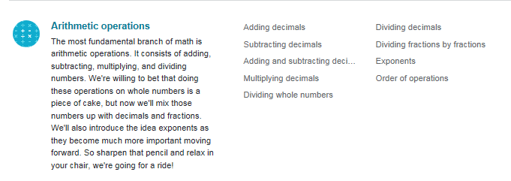
Click here Arithmetic Properties
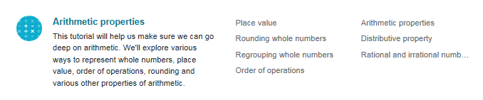
Click here Negative Numbers and Coordinate Plane
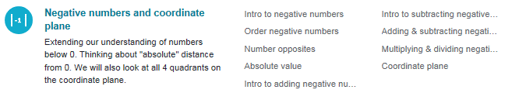
Click here Fractions
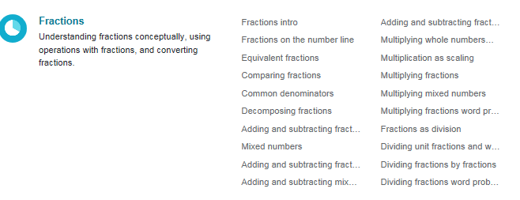
Click here Decimals
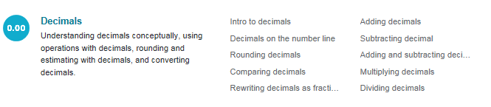
Click here Changing Fractions to Decimals

Click here Convert Decimals, Fractions, Percent

Click here Measurements
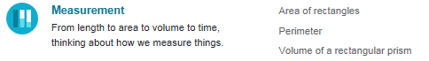
Click here Ratios, Rates, Proportions

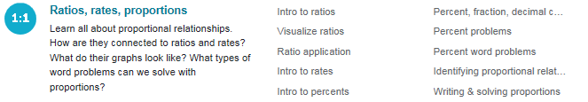
Click here Reading and Interpreting Data

